Software Requirements Specification
for
Augmented Reality Based Scanner
Version 1.0
Prepared by:
Shivam Mittal (101603316)
Satwik Tripathi (101610081)
Shagun Kaushal (101610082)
Shivam Bhushan (101783039)

Instructor: Dr. Sanmeet Bhatia
Course: Software Engineering
Lab Section: COE 21
Teaching Assistant: Ms. Shivani
Date: 16th October 2018

Introduction

Purpose
The purpose of this document is describing the Augmented Reality Based Scanner. Aim of the project is combining Augmented Reality (AR) and software development workflow process and providing information of scanned images or text to users. This document contains particularized information about the project and requirements of the project. The document indicates the recognized constraints and requested software functionalities.

Document Conventions
This document follows the IEEE formatting requirements.
- Times New Roman font size 12 throughout the document for text.
- Italics for comments.
- Larger font size for sections and title headings.

Intended Audience and Reading Suggestions
This project is a prototype for the intra-university Augmented Reality based Scanner system and it is restricted within the college premises. This project is useful for accessing information about different objects or places using application developed in Unity. Target audience for the application are students and staff members.

Product Scope
Augmented Reality Based Framework is an augmented reality based application project that has the purpose of scanning the surroundings through a camera and projecting an image that can act as a guide cum virtual projection of the surrounding. We plan to implement these functionalities for an audience of Thapar university students and staff members.
The AR Scanner System is to be implemented in the following three phases:
1. Pilot Phase: Here the AR scanner including access control will be implemented at the university level. Initially we will be providing access privileges for three types of users: Students, Staff and Admin as they will be ones most involved in this phase.
2. Institute wise deployment: Following the successful completion of the pilot phase, we plan to deploy the same across city and functionalities of AR Navigation and Art Draw will be implemented.
3. Extension of AR Scanner system to other applications: In the future we can have train our project using computer vision to give information about the objects scanned.
Here the same functionalities will be implemented in each phase; the only difference will be the addition of AR Navigation, Art Draw being carried out and the scale of implementation using computer vision.

References

IEEE SRS Format Standard 830-1998

Software Engineering by Ian Sommerville

http://www.techwrl.com/techwhirl/magazine/writing/softwarerequirementspecs.html

Overall Description

Product Perspective
Augmented Reality Based Scanner is an augmented reality based application project that has the purpose of scanning the surroundings through a camera and projecting an image that can act as a guide cum virtual projection of the surrounding.

Product Functions
On opening the AR Scanner Android Application, login activity will be opened for registration of new user or log in of existing user. After log in, user will interact with main functionality of app. Activity for scanning will appear where user will scan the predefined images or text. On scanning the particulars, virtual user interface or certain object will appear on the screen using augmented reality consisting of the information for particular scanned element. Appearance of information using augmented reality will be in virtual world with respect to the real world. Users can also change avatars for interacting strongly with real world. Further development of project includes navigation to particular location in the university premises searched by the user and art drawing in augmented reality using Google AI Experiment plugins.

Operating Environment
Devices: Android smart phones and tablets with Gyroscope support.
Operating System: Android 6.0 (Marshmallow) or above.

Design and Implementation Constraints
Hardware Constraints: The system requires a database to store persistent data. The database should have backup capabilities. Vuforia target manager database is a developer portal that allows you to create databases of targets for use on the device and the cloud.
Software Constraints: The development of the system will be constrained by the availability of required software such as Unity 3D and Microsoft Visual Studio. Vuforia Augmented Reality SDK that enables the creation of augmented reality applications. Support of Android SDK and Java JDK also.
Language Used: C#

External Interface Requirements

User Interfaces
Our goal is to develop a software that should be easy to use for all types of users – Student, Staff Member and Admin. Thus, while designing the software one can assume that each user type has the following characteristics:
1. The user has an android smart phone and has no difficulty in using the application.
2. In order to use application a user must be aware of the internal working but he/she is expected to know what happens

Hardware Interfaces
Smart mobile devices which should include:
  - Gyroscope Support - For operations of Augmented Reality.
  - Camera - For scanning of images or text.
  - Touch Input - For control of Virtual Objects.

Software Interfaces
- Database - Vuforia target manager database which stores image targets.
- Project Build - Android Application to use on smart phones with gyroscope support.
- Development Tool - Unity 3D IDE.
- Code Platform - Microsoft Visual Studio.

System Features

Functional Requirements
Purpose: To display information regarding the scanned objects in augmented reality.
Input: Scanning of image or text through the application developed in Unity 3D provided device is gyroscope supported.
Processing: Checking of image or text from the Vuforia target manager database for displaying the information respective to the object.
Output: Information on mobile screen in Augmented Reality concerning to the scanned element.

Ishikawa Diagram

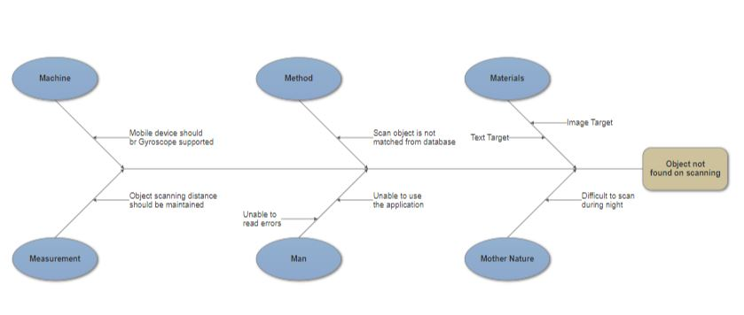

Fig 1: Ishikawa Diagram

Use Case Diagram

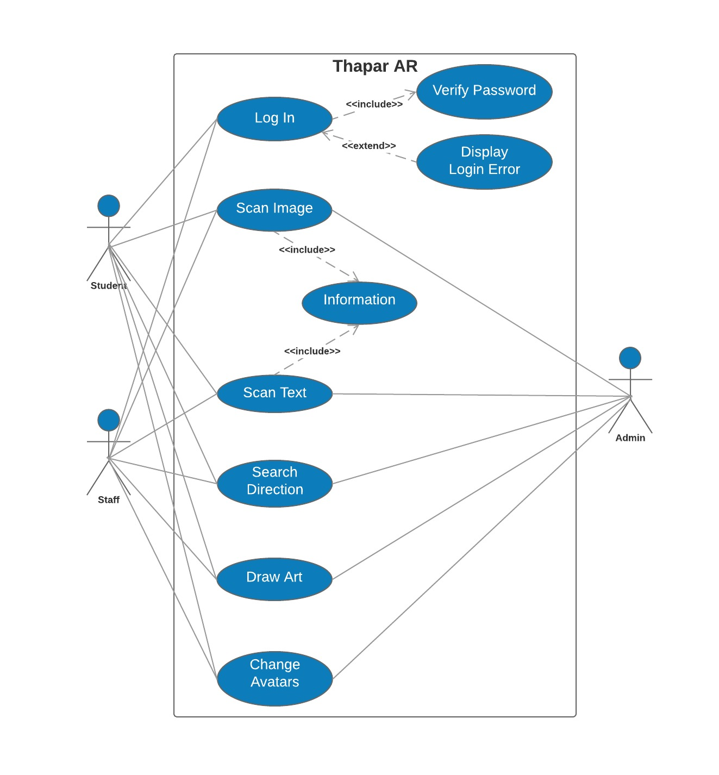
Fig 2: Use Case Diagram

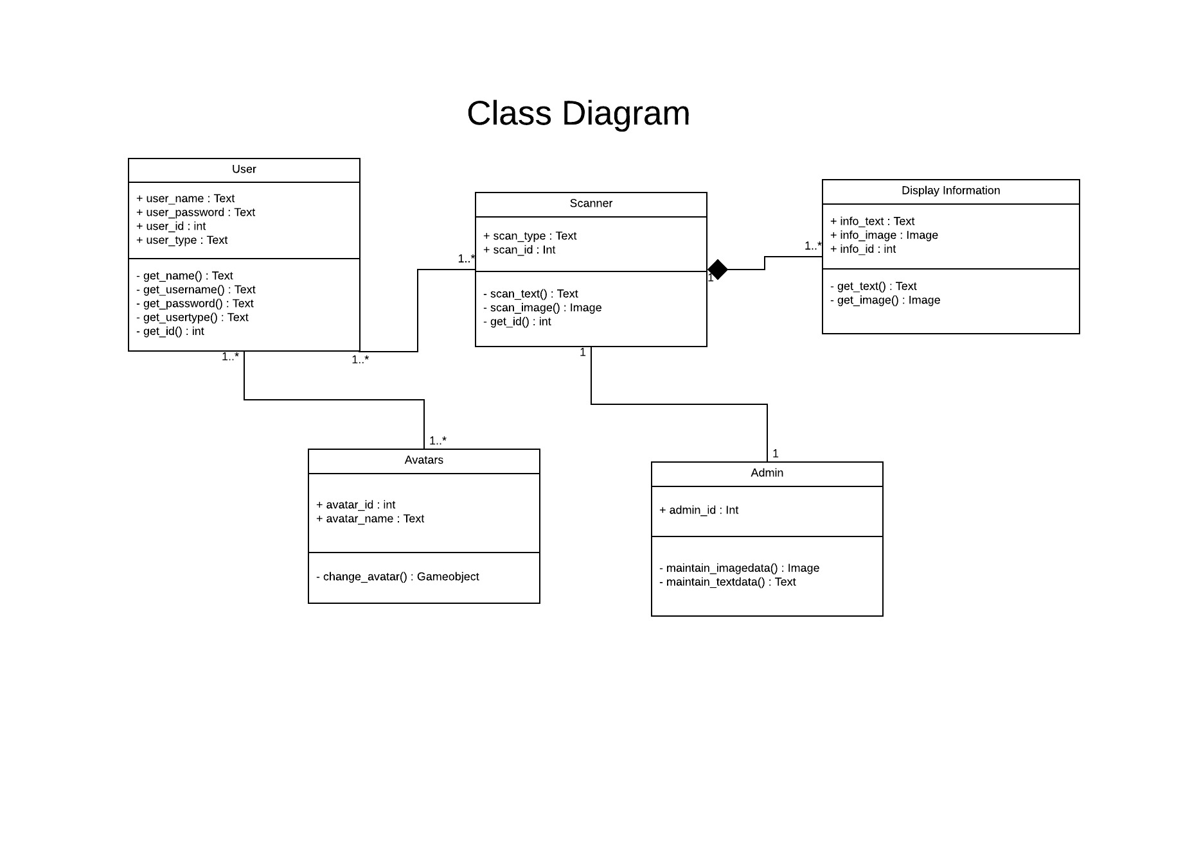
Class Diagram

Fig 3: Class Diagram

Activity Diagram

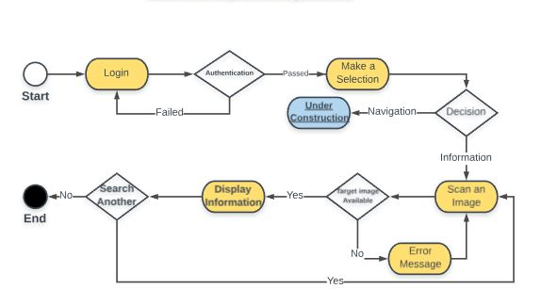

Fig 4: Activity Diagram

Data Flow Diagram
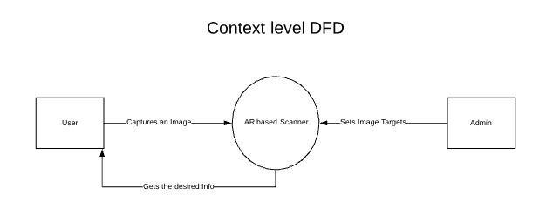
Fig 5: Level 0 DFD

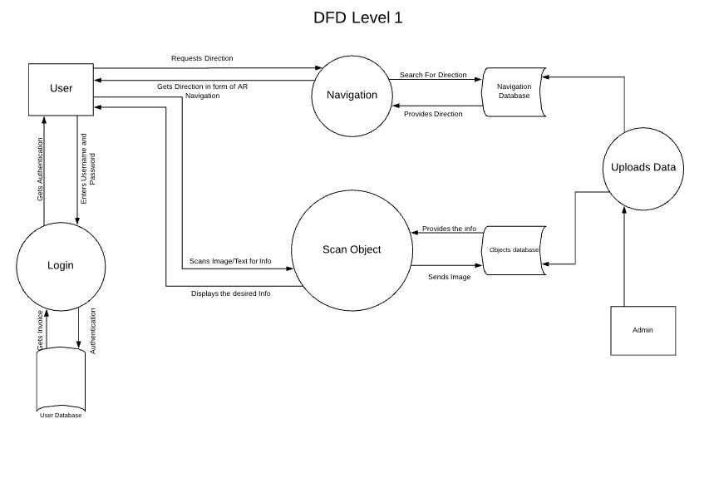
Fig 6: Level 1 DFD
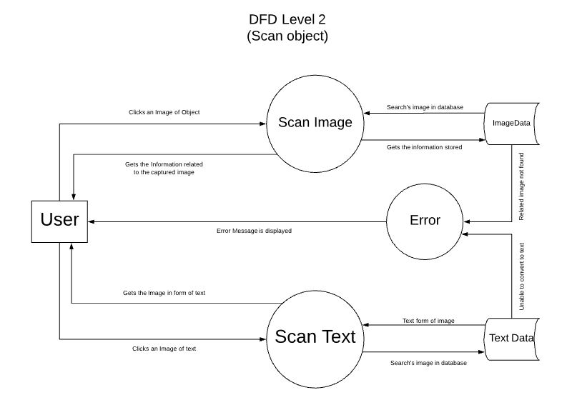
Fig 7: Level 2 DFD (Scan Object)

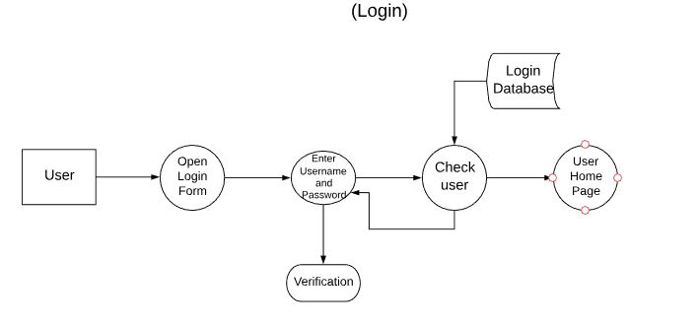

Fig 8: Level 2 DFD (Login)

Non-functional Requirements

Performance Requirements
System’s visual must run smoothly without any latency to keep the level of immersion high. This requirement is depended on many aspects of the user mobile device/tablet.
System will be developed by using Unity 3D and Vuforia; therefore, versions of Unity3D and Vuforia must support the mobile devices/tablets OS. Unity3D version must be the latest version (2018.2+) and Vuforia version must also be the latest version (7.1+). For Vuforia to be worked on mobile devices/tablets; Android OS must be Android 6.0+.

Safety Requirements
Since the system is working on mobile devices/tablets and AR devices, user must be careful while they are moving around. System may show them virtual objects or images or texts which are not real but these virtual objects, images and texts may appear on real objects.
While using the system, users may not notice the real objects and these object can cause injuries. Therefore, while looking at the screen and moving, user should watch out the area and take his eyes off the screen in every few seconds to check the real environment.
Too much mobile device exposure can cause occurrence of some symptoms of radiation such as headache, insomnia, tiredness, sleep disruption, eye strain and many more

Security Requirements
Security is one of the key elements of the project, therefore strict rules are followed about confidentiality of users. There shall be no login to the system other than the students and staff members of the university. Also, standard users shall not access to the admin authorization pages.
If there is extensive damage to a wide portion of the database due to catastrophic failure, such as a disk crash or Vuforia target manager database crash, the recovery method restores a past copy of the database that was backed up to archival storage.
Security systems need database storage just like many other applications. However, the special requirements of the security market mean that vendors must choose their database partner carefully.

Software Quality Attributes
- Portability: Augmented Reality Based Scanner is designed for mobile devices/tablets using Unity 3D and Vuforia. Unity3D supports many of the mobile devices/tablets, so system can be used mobile devices/tablets if their OS versions are supported.
- Performance: The distance between the camera and the image shall not be more than 0.5 meters to scan. Scan operation can last till the image target under AR camera scanning.
- Usability: The software is planned to be used by software engineers whom are expected to be experienced mobile device and application users. Even so, the usability should be as simple as possible since the screen of a mobile device is not big enough to place many information. New users are able to learn using the system in 5-15 minutes.
- Availability: System shall be available to all its user in the university.
- Scalability: Multiple users can use the system with their own mobile devices, tablets and AR compatible devices. The first version of the system is planned to be used by a group of 4-6 people.

